# WEB DESIGN RESEARCH REPORT

## CALICO AIR

**BRIEF:**

Calico Air wants a design for their new online booking system in the wake of the changed climate of travel due to COVID-19. Must include:

* A live updates page where users can keep track of any changes.
* A flight booking page where users can view the flight options and book according to their needs.
* A discovery page where users can discover places that they may not have been familiar with?

**RESEARCH:**

Calico Air’s target audience would be people who want to travel (purchasers are normally over 18 years old).

The general design theme wanted is a simple yet elegant and communicative. A moodboard for the two concept designs are attached as Pinterest board here

1. <https://pin.it/1EdwKDI>
2. <https://pin.it/2YXKTcs>

**DESIGN 1:**

<https://www.figma.com/file/Qa22TiEoJlj4qIxcqCEwkY/Calico-Air-2>

For the first design, I went for a very strong bold colour blocking theme that makes it stand out among other. The first page creates a strong first impression with a bold big font with an interactive box below that rotates out different countries/flight’s destinations every few minutes that fits with both the theme and the quote used in the front page.

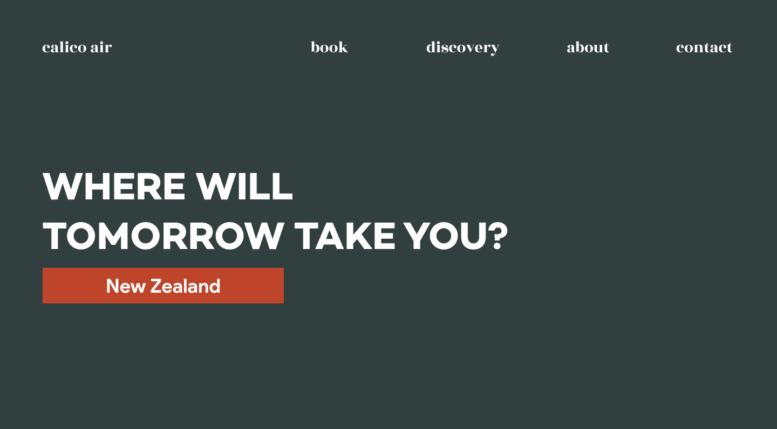

On the search for flights page, a simple rectangular backdrop that is reminiscent of a plane ticket that contrast nicely with the deep green blue background. Users enter and is immediately shown what they click on the page for which is good UX. This fulfils the client’s need of a flight booking page/system.

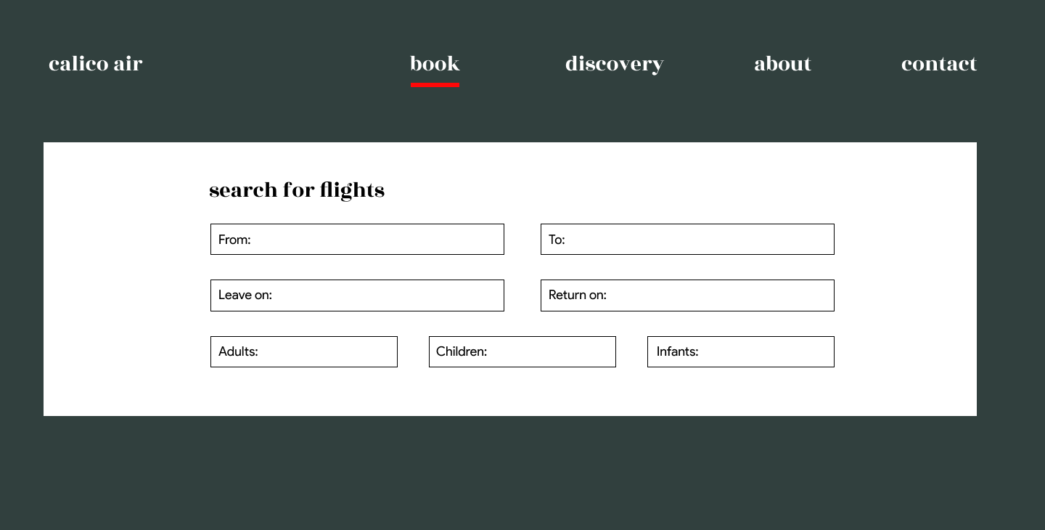

On the discovery page, using a mix of beautiful photos I think it really showcases the beauty of each experience the country has to offer. Whilst its blocky I think the image creates a good contrast in between for it to not be boring as your scroll through the page. Its both visually interesting and the format is cohesive for a good user experience. This fulfils the client’s demand for a discovery page for which users can see information on places they are unfamiliar with.

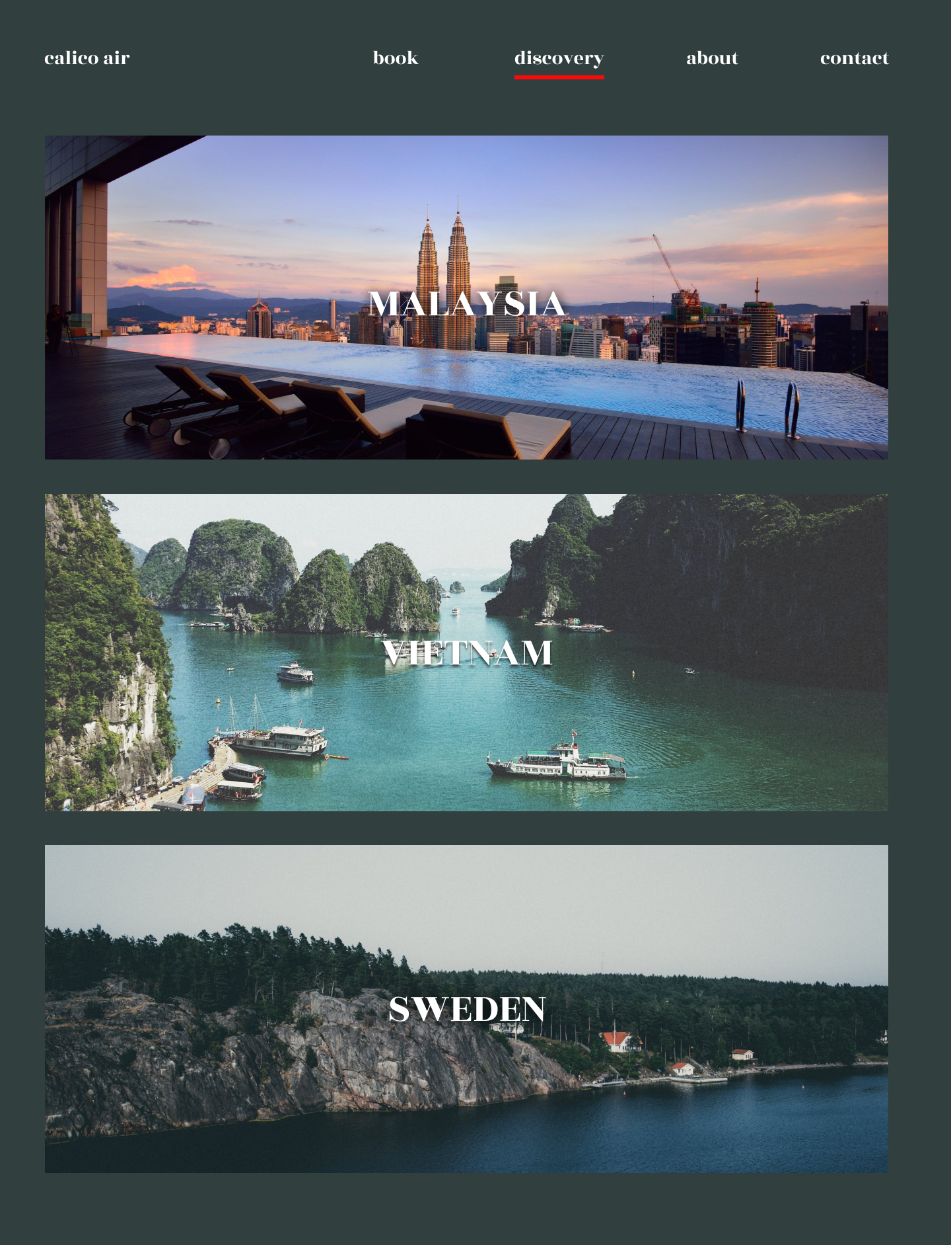

On the about page, I decided to also put a live update section here and when there is an update, the about button will be backed with a red rectangle to draw the user into clicking into the page!

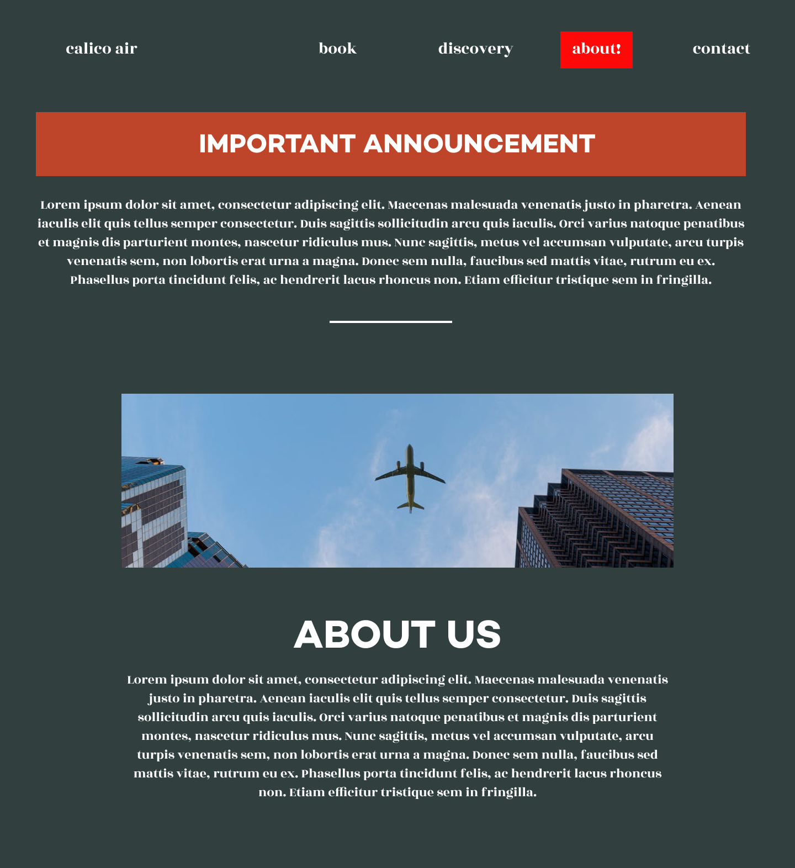

A mix of san-serif and serif font create a beautiful contrast that feels very luxurious to browse. The coherent design with a distinct colour palette creates a consistent flow throughout all the pages.

**DESIGN 2:**

<https://www.figma.com/file/yS5QnqalB8dDi7NMCwixXW/Calico-Air-1>

For the homepage design, I went for a bold yet minimalistic look that, in reverse to the other design, use serif font as the title/accent texts and sans-serif for everything else. A limited colour palette or white, black and a hint of orange creates a sense of high-class travel and clean aesthetic. I decided to also integrate the client’s demand of a live update part into the home page itself as a very distinct black box. This means that users can immediately absorb the necessary/important updates from the very first visit to the website or for users who want to quickly check.

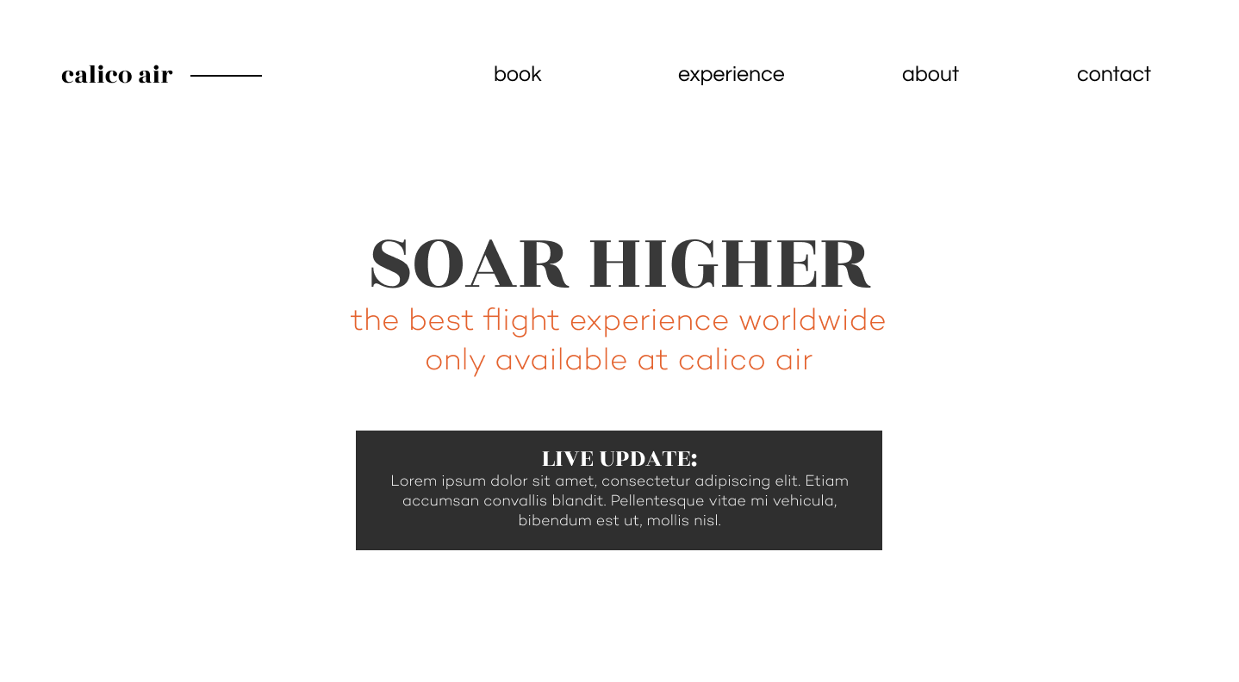

For the next page, which is the flight search engine, I opted for a bigger yet still simple looking search interface that’s left-aligned and added an image to the side for extra visual interest and a pseudo-prompt for the user to book using subconscious imagery.

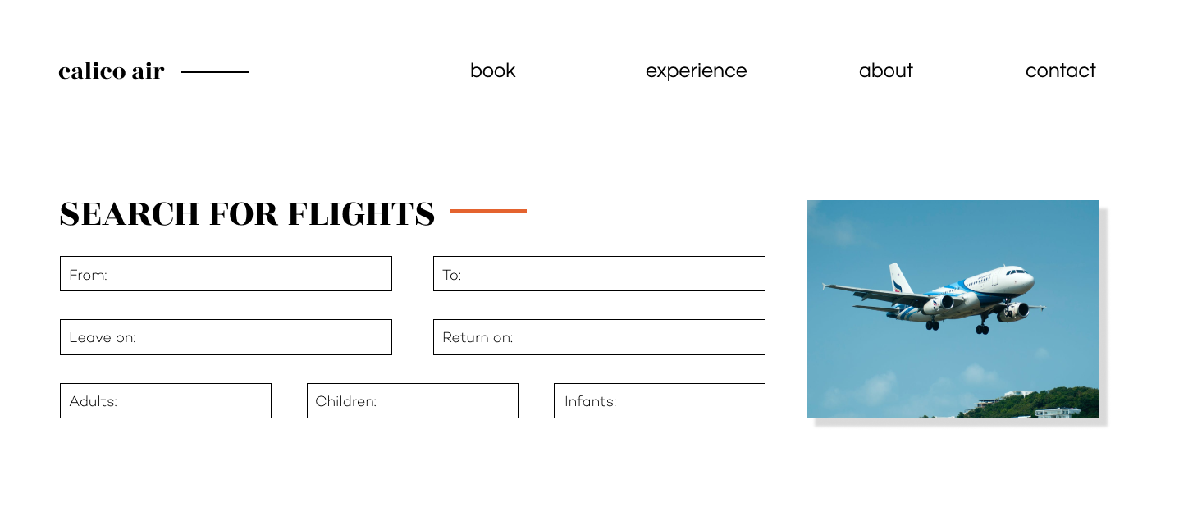

For the last page, which is the discover page as requested by the client. I decided to take a quantity over quality result. Where the first design draws from big beautiful images, I want this one to be where the user can view all the experiences Calico Air has to offer. This shows the variety and range the brand has highlight in a beautiful minimalistic format that shines a light on the imagery rather than just text.

